ARRL EMC Committee Semi-Annual Report
Doc. # 21
For The
American Radio
Relay League
Board of Directors Meeting
July 16-17, 2010
Submitted By
Kermit Carlson, W9XA
Chairman, ARRL EMC Committee
Mission Statement:
The EMC Committee monitors developments in the Electromagnetic Compatibility (EMC) field and assesses their impact on the Amateur Radio Service. The Committee informs the ARRL Board of Directors about these activities and makes policy recommendations for further action, if appropriate.
The overall goals of the committee are:
- Advise the ARRL Board about issues related to radio-frequency interference
- Advise the ARRL HQ staff on the content of its publications
- Make recommendations to the ARRL Board and HQ staff
Members of the Committee:
- Mr. Kermit Carlson, W9XA, ARRL Central Division Vice Director, EMC Committee Chairman
- Mr. Jody Boucher, WA1ZBL, RFI troubleshooter, Northeast Utilities
- Mr. Brian Cramer, PE, W9RFI, Electrical Interference Solutions, Inc.
- Mr. Mike Gruber, W1MG, ARRL Lab RFI Engineer, HQ Staff Liaison
- Mr. Ed Hare, W1RFI, ARRL Laboratory Manager
- Mr. Ron Hranac, N0IVN, Technical Leader, Cisco Systems; past member of the Board of Directors, Society of Cable Telecommunications Engineers
- Mr. Steve Jackson, KZ1X, VDSL and wireless communications
- Dr. Ron McConnell, W2IOL, T1E1.4 VDSL Standards Committee
- Mr. Jerry Ramie, KI6LGY, ARC Technical Resources, Inc.
- Mr. Cortland Richmond, KA5S, EMC Engineer
- Mr. Mark Steffka, WW8MS, Automotive EMC engineer
- Dr. Steve Strauss, NY3B, Home Phone Networking Alliance Technical Committee
- Mr. Brent Zitting, KB4SL, International Broadband Electric Communications. Inc. (IBEC)
- Mr. Hugh Turnbull, W3ABC, ARRL Honorary Vice President, EMC Committee Member Emeritus
HQ Staff:
The role of the ARRL HQ staff consists of the following:
- Answer individual inquiries from hams (and sometimes their neighbors) about RFI problems
- Write and publish articles about RFI
- Write and publish the ARRL RFI Book
- Design and update ARRL's RFI web pages
- Maintain a database at ARRL to facilitate EMC case tracking and reporting
- Work with ARRL's D.C. office on various spectrum and RFI-related filings
- Maintain contact with industry
- Participate in standards and industry groups, as a voting member or as a liaison. This includes ANSI accredited C63®, Society of Automotive Engineers EMC and EMR committees, Home Phone Networking Alliance, VDSL, HomePlug, FCC and individual companies.
Mr. Gruber handles the majority of the staff work on EMC matters. In the 1st half of 2010, he also continued with work in a number of key areas:
  - Adding updates to the ARRL RFI Web pages. Some of this effort was driven by the new ARRL Web site.
  - Adding updates and new material for the 3rd Edition of the RFI Book. Significant contributions for the new edition were also added by Committee members Ron Hranac and Mark Steffka.
  - Developing and writing a new EMC Chapter for the 2011 ARRL Handbook.

Mr. Hare submitted an IEEE Project Authorization Request for a proposed IEEE Recommended Practice document for utilities to handle a power line noise complaint. This project was considered by the IEEE Electromagnetic Compatibility Society Standards Development Committee (SDCom) at its August 2009 meeting. Mr. Hare continues to report considerable interest among his electric-utility contacts. As previously reported, Mr. Gruber had completed a rough draft of this document during the first half of 2009. SDCom has approached the IEEE Power and Energy Society to join as a co-sponsor. Discussions are underway that will allow the proposed scope of the document to meet the needs of both groups.

First Half 2010 Year Total RFI-case statistics:
New RFI Cases – 154
New electrical power-line cases – 49
- ARRL Letters sent – 33
- FCC 1st Letters submitted – 9
- FCC 2nd Letters submitted – 1 (Note: Laura Smith had issued a number of FCC letters based on need and input from the ARRL. These letters were not formally submitted by ARRL. Many of these letters were follow-up in nature and therefore required custom legal language.)
Electric Utilities:
Power-line interference has continued to be the single number one known interference problem reported to ARRL HQ. Interference cases, including power line noise, had been pretty much on track since Laura Smith was hired on January 20, 2009. Earlier this year however, Ms. Smith had been out of the office for several extended periods of time, including maternity leave. As a result, it appears that these cases have fallen behind at the FCC.

Mike Gruber reports he has not had an in-depth telephone conference with Ms. Smith since she’s been away. Mr. Gruber hopes this will only be a temporary set-back. Furthermore, Ms. Smith clearly remains interested in RFI enforcement and continuing with the Cooperative Agreement, a process of having the FCC contact power companies about interference complaints.

Of particular interest are four cases that have previously been reported in semi-annual reports. Each case remains ongoing since January with little or no forward progress. Here is the current status of each case:

- W1JA in Suwannee, Georgia: This case had resulted in a formal field investigation by the Atlanta Field office in May of 2007. Although this case had been ongoing for several years with no resolution, the FCC Field Agent later concluded the complainant should continue to work with the utility as he had been. John Pelham, W1JA, the complainant in this matter, reports the noise continued with little or no abatement after the investigation.

Mr. Gruber had to opportunity to visit the site of this complaint in November, 2008 and found four offending sources in about an hour’s time. This case remains ongoing but the utility is still actively working on it. Since the noise is only a problem during cool and dry weather, the interference diminishes during the summer months. The complainant continues to keep the utility, ARRL and FCC advised of any changes. This case was first reported to the ARRL in March of 2005, over five years ago.

- W4FGC in Lakeland, Florida: This previously reported case also remains ongoing. At the present time, there doesn’t appear to be any active effort by either the FCC or utility to correct this problem. This case was first reported to the ARRL in January 2003, over nine years ago. Mr. Gruber is hoping for a personal meeting with Laura Smith to discuss this case, among others.

- W0ZK in Northglenn, Colorado: This is another case previously investigated by Mr. Gruber. Mr. Gruber reports he was able to locate two noise sources during his investigation. A third source noted but went away before it could be pinpointed. Mr. Gruber’s subsequent report was sent to Laura Smith at the FCC for action. Although a number of letters between the utility and FCC have been sent, it remains ongoing with no resolution. It was first reported to the ARRL in February 2008, over two years ago

- W2PM in Ramsey, NJ: This case involves a 69 kV transmission line tower in the complainant’s backyard. In this case, the utility’s RFI investigator concluded that there was a composite of noises that were being generated all along the line. The problem was not fixable. Based on a recording of the noise, Mr. Gruber concluded that there were only two noises affecting the complainant’s station. Mr Gruber found the two sources in November of 2009. Based on his reports, the utility’s RFI investigator took a second look. He concluded there were hardware issues with approximately four towers that needed replacement. These towers were somewhat unique as a result of hardware incompatibility when the voltage was increased on the line several years ago to 69 kV.

The utility’s RFI investigator informed Mr. Gruber that they would need to shut down the line in order to make the repairs. The repairs were expected to be completed before the start of the air conditioning season. The repairs were never started, and the utility never contacted the ARRL or complaint to advise of the schedule change. The case has now gone to the FCC.

The case remains ongoing with a questionable good faith effort on the part of the utility to fix it. It was first reported the ARRL in May of 2009. Mr. Gruber believes it is substantially fixable and would make a great example case for stations near high voltage transmission lines. RFI investigator Mike Martin also visited the site in June and confirmed Mr. Gruber’s findings.

Mike Martin, K3RFI of RFI Services conducted an RFI Workshop at ARRL HQ in June. Plans and discussion remain ongoing to conduct a specialized version of the Workshop for FCC personnel in Gettysburg.

Committee Membership

On behalf of the EMC Committee and myself, I wish to extend a warm welcome to our newest member, Brian Cramer, W9RFI. Brian brings a wide range of professional experience in the EMC field, with particular emphasis on power transmission and distribution systems. Welcome Brian.

PAVE PAWS

Mr. Hare has continued to work with Dan Henderson, Paul Rinaldo and Chris Imlay to analyze PAVE-PAWS interference and systems. Ed has been running Longley-Rice propagation calculations on repeaters, helping to identify ways that some of the repeaters on “the list” of repeaters requiring mitigation can be kept on the air.

Broadband Over Power Line (BPL):

Broadband over power line (BPL) is the use of electrical wiring or power-distribution lines to carry high-speed digital signals. There are two types of BPL of concern to amateurs. Both in-building and access BPL have signals that occupy most or all of the HF range, extending into VHF. The power-line or electrical wiring can act as an antenna and radiate these signals. In-building BPL can be used to network computers within a building. It uses the building wiring to carry digital signals from one computer to another. Most in-building BPL operates under the HomePlug industry specification. Access BPL provides broadband Internet access to homes and businesses, using a combination of techniques and wiring. Although some BPL feasibility trials have shut down, the number of utilities trying access or utility-applications BPL continues to be slowly increasing. In-building applications are also on the rise.

In general, the number of BPL installations in 2010 has been declining. Major systems have shut down, such as the ones in Houston, TX; Manassas, VA and Briarcliff Manor, NY.

- The primary focus points toward BPL to continue to be deployed in rural areas, subsidized by US-government loan, multi-dwelling and in-home BPL and grid automation. The company that is installing these rural systems has continued some notching of Amateur bands, but it has changed over from a policy of fixed, permanent notches to adding notches to the Amateur bands only in response to interference to fixed Amateur stations.
- Mr. Hare continues to represent Amateur Radio’s stake in BPL standards development on various industry committees. These include the IEEE P1775 BPL EMC committee; the IEEE EMC Society Standards Development Committee and ANSI ASC C63® The IEEE P1775 BPL EMC standard has passed its initial ballot, and is in the process of having ballot comments resolved. Among those comments were concerns expressed by the IEEE EMC Society, through its Standards Development Committee. As of this time, those comments were not accepted by the P1775 Working Group.

ARRL’s information on BPL is found at www.arrl.org/bpl.

Jerry Ramie also reports the following related activities during the first half of 2010:

- The ARRL white paper "Electric Utility Communications, Applications and Smart Grid Technologies" posted at
www.arrl.org/electric-utility-communications-applications-and-smart-grid-technologies
was previously edited into three PowerPoint versions for delivery to Communications, Power and EMC audiences. Each version features the League's logo on the opening slide and the ARRL white paper in the Bibliography as a major source. The EMC version was previously submitted to the IEEE - EMC Society Distinguished/Respected Lecturer program for consideration. A variant of the Presentation was given in-person at several previously mentioned locations and venues. Two new variations have now been added for utilities.

- A previously described PowerPoint report, commissioned by the League under its logo, on the inaugural activities of the P2030 Smart Grid Interoperability Guide working group meetings was repurposed and given by Andy Drozd, the Chairman of the IEEE EMC Society Standards Development Committee and Past President of the EMC Society. Mr. Drozd gave this report to a workshop at Connectivity week in Santa Clara in June.

- The W6MQI complaint investigation was begun in Livermore, CA for ARRL on 12/22/09 appears to have been resolved. The initial complaint was about a weak, In-Premises BPL modem pair, probably DS2 chips, operating un-notched across all of 20m. The interference received at the complainant's station probably didn't meet the definition of "harmful interference" since CW stations near the OFDM carriers (spaced at 1.1 kHz) could still be heard clearly and copied. Upon the second visit, however, two local, strong (S7) sources were evident at 14.030 MHz. These probably did meet the definition of "harmful interference," as they prevented the copying of desired signals. One appeared to have been broadband leakage from a cable TV head-end distribution amplifier. The other appears to be a clock (CW) signal at 14.030 MHz from a residential roof-top solar installation's controller, inverter or other Pt. 15 device within the home.

The cable TV head-end has now been replaced. The last report concerning the noise at 14.030 MHz noise indicates that it was coming from a neighbor’s house four doors to the west. No further contact was initiated.

Automotive EMC:

The Headquarters staff continues to send all reports of automotive EMC problems to interested people in the automotive industry. While these reports are advisory, they are helpful to the industry in planning for future designs. Mr. Steffka also helped prepare some responses to Technical Information Services (TIS) questions for ARRL members.

Mr. Steffka also assisted in review and development of EMC related material for the 2011 ARRL Handbook. In addition, he provided input on the automotive chapter for the Third Edition of the ARRL RFI Book. Mr. Steffka also introduced Jeremy Campbell, KC8FEI to Mr. Gruber while working on the RFI Book. Mr. Campbell wrote an important sidebar on hybrid vehicles, his specialty, for the book. He also wrote most of the Automotive section for the 2011 Handbook.

Mr. Hare continues as the ARRL representative on the Society of Automotive Engineers EMC (Electromagnetic Compatibility) and EMR (Electromagnetic Radiation) Committees.

Cable Television:

As a whole, the cable industry continues to do a good job at adhering to the FCC's regulations about signal leakage and interference. ARRL has received only a few reports of problems, indicating that most systems are either clean or are addressing complaints effectively. Only a handful of these cases have required Mr. Hranac’s involvement and ARRL follow up. Mr. Hranac also contributed cable- and DTV-related technical material to the 2011 edition of the ARRL Handbook and the new 3rd Edition of the ARRL RFI Book.

Wind Turbines:

Brian Cramer reports the following related activities concerning wind turbines during the first half of 2010:

In March of 2010, Brian Cramer and Jerry Ramie observed emissions from Wind Turbines in three Wind Farms in Benton County, Indiana. This investigation was the result of interference problems experienced by a 2-meter USB user in Illinois. In each case, they listened to sample wind turbines at close range using a Yaesu FT-817 transceiver and a 3-element Arrow Yagi tuned to 121.5 MHz and operating in USB (they did not have a 2-meter beam antenna with them for 144.2 MHz testing).

The first group of turbines measured produced a 15-kHz interval comb that was clearly discernable from 100m in USB. Two turbines were assessed from this group with the same result. In each case the S-meter did not register (e.g. S0). The comb was strongest when the turbine was facing the receiver, and weaker when facing away. This tends to indicate that the source is probably in the hub. The noise was inaudible using FM demodulation.

The second group of wind turbines appeared similar to the first with a different shape of the back of the nacelle. These turbines had no discernable noise at 100m.
The third group was very different in appearance. These turbines had no discernable noise at 150m (as close as they could get).

Based on these observations, the conclusion is that these wind turbines should not pose a wide-spread interference problem. Should harmful interference occur, it should be resolved on a case-by-case basis.

Home Phone Networking Alliance

Dr. Strauss reports there are no issues relative to EMI [conducted or radiated] that have been reported that he is aware of during the past quarter. Dr. Strauss' company also no longer participates nor supports HPNA technology.
Database:
The ARRL HQ staff maintains a database of RFI reports and cases. This is used primarily as a case-management tool for the several hundred RFI cases ARRL handles every year, but the information the Lab staff are gathering about types of interference cases, involved equipment and frequencies will provide a wide range of reporting capability. Here are some statistics from the database for the 1st half of 2010 and compared to the two previous years:
Category of Case Reported to ARRL Lab/EMC Engineer | 2008 | 2009 | 2010
BPL | 2 | 1 | 3
Unknown Unintentional Radiators | 49 | 65 | 25
CABLE TV | 11 | 26 | 5
Computing Devices and Modems | 15 | 21 | 3
Power Line Noise | 81 | 113 | 46
Plasma TV Receivers | 8 | 12 | 5
Other Broadcast Receivers | 3 | 2 | 3
Other Receivers | 1 | 4 | 2
Other Transmitters | 11 | 1 | 0
Broadcast Transmitters | 2 | 2 | 1
Lighting Devices | 12 | 12 | 7
Fence Systems | 3 | 4 | 4
Battery Chargers | 6 | 2 | 1
Wheelchair | 0 | 0 | 1
Water Pump Systems | 1 | 1 | 3
HVAC Systems | 5 | 4 | 5
Alarm Systems including detectors | 3 | 4 | 3
Other Appliances | 12 | 7 | 1
GFIC | 5 | 1 | 0
AUTOMOBILE Systems | 12 | 8 | 2
Manufacturing and Retail Generated Noise | 1 | 2 | 0

Data from this table now appears in tabular form. It is important to note that power line noise has consistently been the most reported and problematic RFI problem reported to the ARRL Lab. As Committee member Ed Hare indicted, more hams suffer from power line noise right now than will ever suffer from BPL.

The following graphs indicate the percentage of calls and emails to the ARRL Laboratory and to the ARRL EMC Engineer, Mr Gruber, for help during the years 2008, 2009 and through July 1st for the year 2010 as compiled from the ARRL EMC database. The record clearly indicates that Power Line Noise is the most commonly encountered RFI problem to Amateur installations referred to the ARRL for assistance.

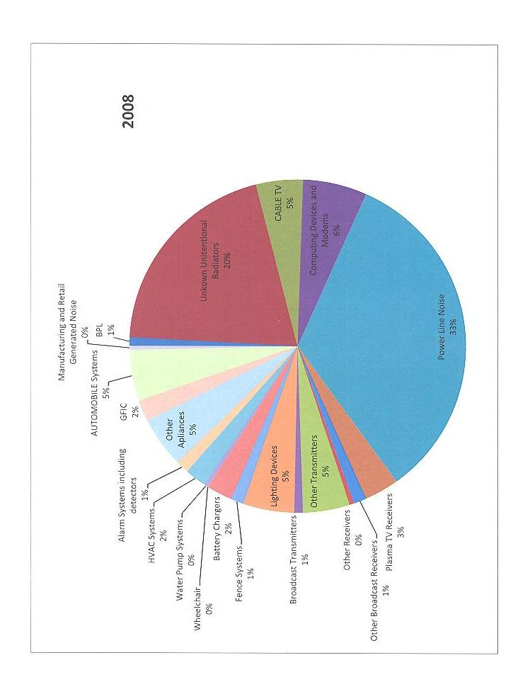
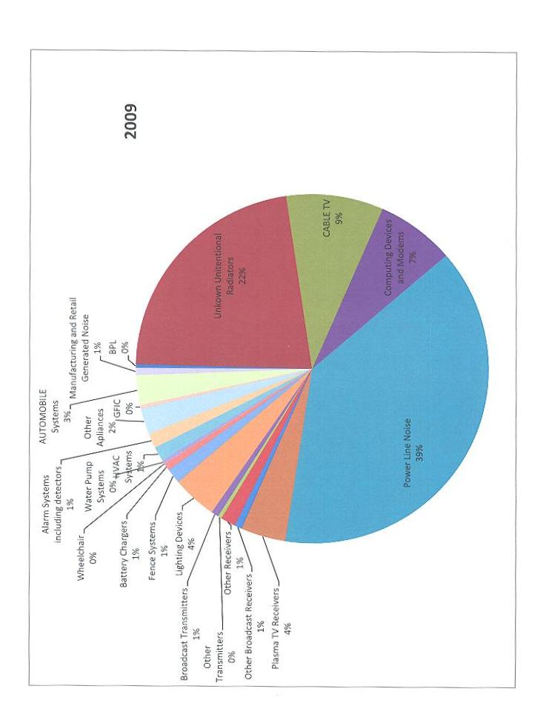
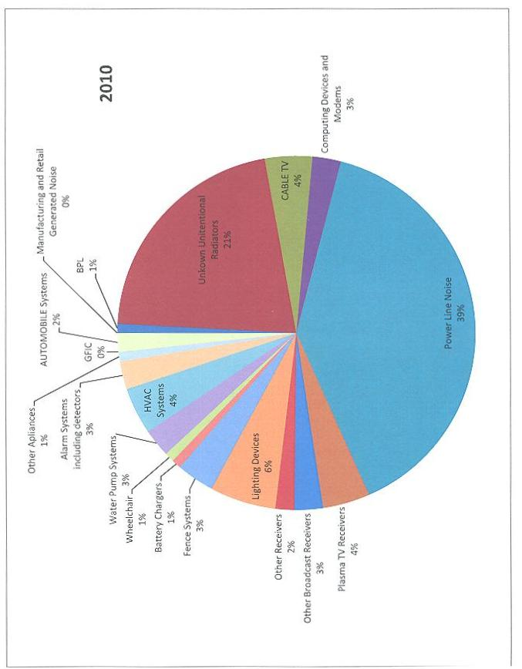
Committees:
ARRL continues to be represented on professional EMC committees. Messrs. Hare and Carlson continue to represent the interests of Amateur Radio on the ANSI ASC C63® EMC committee. Mr. Hare is the Primary ARRL C63® representative; Mr. Carlson is the Alternate. Mr. Hare serves as the Cochairman of Subcommittee 5, Immunity. Mr. Hare also chairs the C63® committee's ad-hoc working group on power-line communications devices. This continues to be a hot topic of discussion at the C63® meetings. Mr. Ramie serves as the C63® Secretary and as a member of the transmitters Task Group.
The C63® committee is working on developing industry standards for immunity, emissions and testing of electronic devices. ARRL serves as a resource to the committee to protect the interests of Amateur Radio. Subcommittee 1 continues to work on a variety of EMC projects, primarily related to test site standardization. Subcommittee 5 deals with immunity and immunity measurement issues. Subcommittee 8 deals with various types of medical equipment. The multiple ARRL EMC-Committee representation on C63 watches immunity and testing developments.
ARRL also continues its participation in the Society of Automotive Engineers EMC and EMR Committees. Mr. Hare is the ARRL representative on those committees. Mr. Steffka also serves on the committees, representing his employment in the automotive industry.
The Future of EMC and Amateur Radio:
Interference to hams appears to be the present major work of the committee. Although immunity problems still do occur, this is being addressed at the national and international standards level. RFI from unlicensed devices poses a major real threat to Amateur Radio at this time. This will continue to require significant Committee and ARRL staff attention. To the extent possible with existing staff, or with additional resources, the ARRL should increase its contact with standards organization, industry groups and individual companies, and continue to work on all aspects of RFI problems and solutions.
ARRL's information about RFI can be read at:
www.arrl.org/radio-frequency-interference-rfi.

Respectfully Submitted,

Kermit A Carlson W9XA
EMC Committee Chairman
ViceDirector Central Division

